# File permissions in Linux

## **Project description**

## I now know what Authorization of files are. I can change the user directory, group directory and other file directory using linux command

## Check file and directory details

Using the (ls -la )command using the ls -l to check file permission and then ls -a to display hidden files

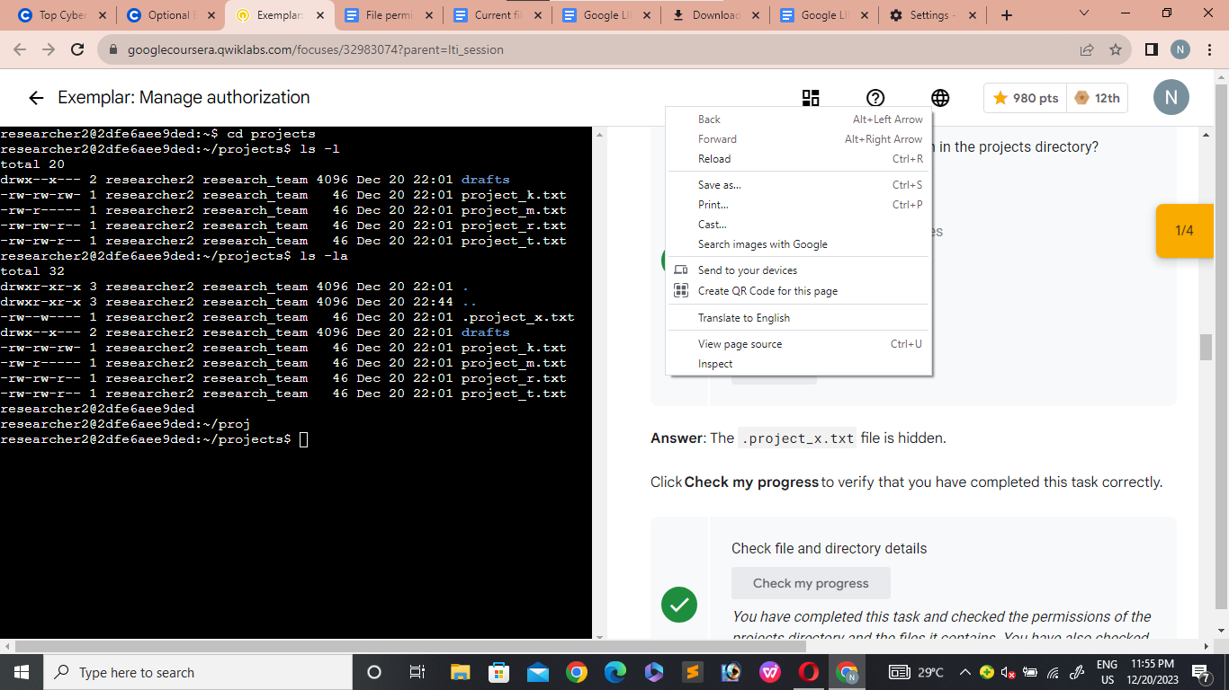

## Describe the permissions string

[Using the Linux

Where

* r is Read file
* w is write file
* x is execute file

Chmod u+rwx this adds and gives the user permission to read,write and execute a file

Chmod u-rwx this removes the user permission

Chmod g-rwx this remove the group permission

Chmod g+rwx this adds group permission

Chmod o-rwx this remove other permission

Chmod o+rwx this adds other permission]



## Change file permissions

[in changing file permissions using the

Chmod u-rwx,o+rwx,g-rwx,g+rwx,o-rwx,o+rwx “The File Name”]

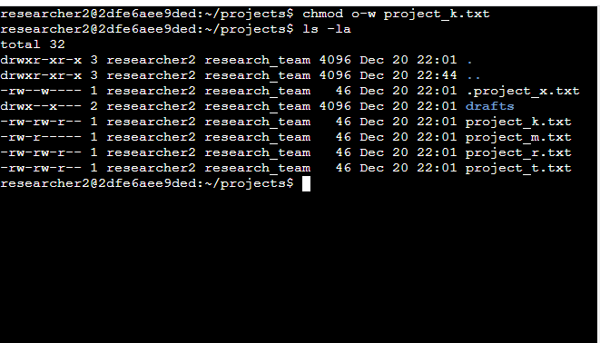

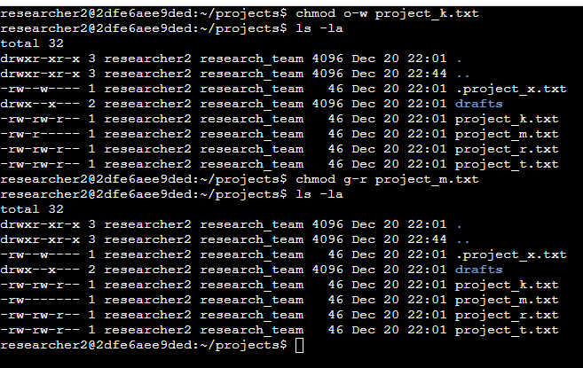

## Change file permissions on a hidden file

[To change file permission on an hidden file

First using a linux command to check the directory

Ls -a

Then use

Chmod u-rxw,u+rwx,g-rwx,g+w,o-rwx,o+rwx “The File Name”]

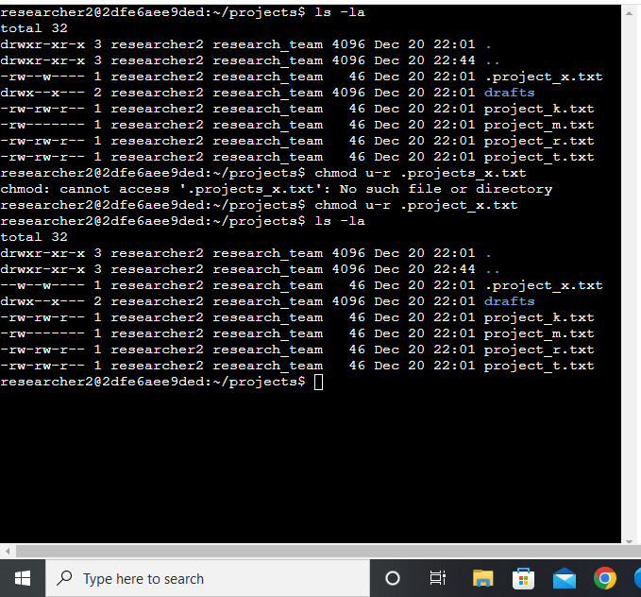

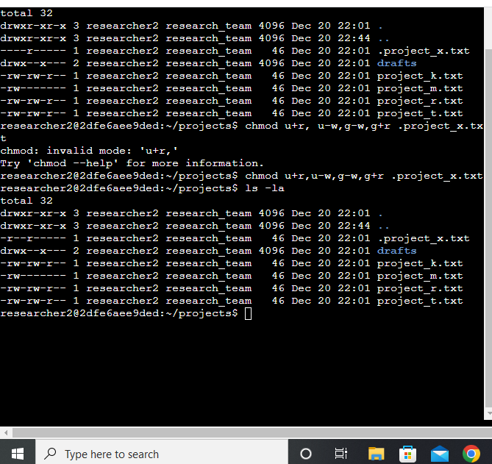

## Change directory permissions

[To change file directory we use the linux command code

Cd “directory name” for example $ cd projects or $ cd /home/analyst/projects]

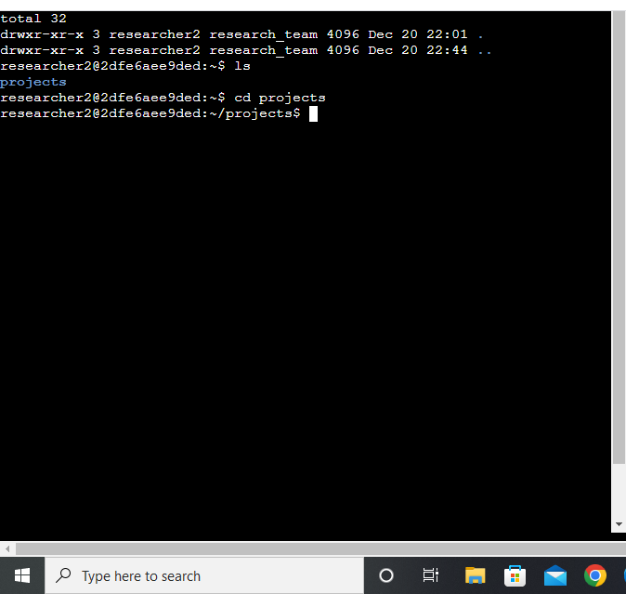

## Summary

[Learning quite a lot so far now i change help any organization with its file permissions giving permission or authorization to the right person or group and denying person or access using the principle of least privilege ]